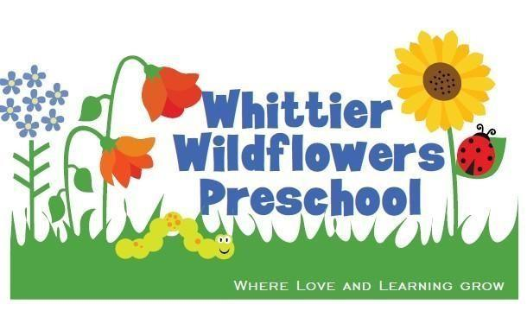

Tuition Guide
September 2018 – May 2019

Tuition Model Overview

We believe quality preschool should be available to and affordable for all families. Using this tuition guide, each family commits to a monthly tuition based on their income and family size.
All families are also encouraged to make an additional Fair Share donation to Whittier Wildflowers that is voluntary and tax-deductible (see page 6).
This Biblical approach is anchored in academic and economic equity, and our love for one another. In addition to other donations raised by the school, this model results in affordable tuition and a sustainable program with high quality teachers.
Instructions:
- Find the appropriate chart based on the age^ of your child and how many days a week you wish to enroll.
- Using your household size and annual gross income (before taxes), please select your monthly preschool tuition amount.
- Decide if you want your child to stay for Lunch Bunch (see page 6 for pricing).
- Consider additional Fair Share, tax deductible pledge using the guide on page 6.
- If you have more than one child enrolled, please apply a 10% tuition discount for each additional child.
If you have questions about age requirements, tuition, Fair Share, or Lunch Bunch, please see your application packet for more info or contact the school.

^ When selecting the right class, use the age of your child as of September 1, 2018.

Toddlers/ Ladybugs:
Two year olds (must be 2 as of September 1st)

Options include 1 or 2 mornings per week

All classes meet 9:00 - 12:00

Tuition listed is monthly

 | 1 day/week | 1 day/week | 2 days/week | 2 days/week
Household  Income | 1-2 children in  household | 3+ children in  household | 1-2 children in  household | 3+ children in  household
$80,000+ | $175 | $165 | $330 | $315
$60-$80,000 | $150 | $140 | $280 | $265
$50-$60,000 | $110 | $105 | $215 | $205
$40-$50,000 | $90 | $85 | $165 | $155
$30-$40,000 | $50 | $45 | $100 | $90
<$30,000 | $30 | $25 | $50 | $45

Preschool/Caterpillars:
Three year olds (must be 3 as of September 1st)
Options include 2 or 3 mornings per week

All classes meet 9:00 - 12:00

Tuition listed is monthly

 | 2 days/week | 2 days/week | 3 days/week | 3 days/week
Household  Income | 1-2 children in household | 3+ children in household | 1-2 children in household | 3+ children in household
$80,000+ | $275 | $260 | $360 | $345
$60-$80,000 | $235 | $225 | $310 | $295
$50-$60,000 | $180 | $170 | $240 | $230
$40-$50,000 | $135 | $125 | $180 | $170
$30-$40,000 | $80 | $70 | $100 | $90
<$30,000 | $40 | $35 | $55 | $50

Pre-K/Butterflies:
Four year olds (must be 4 as of September 1st)

Options include 3, 4 or 5 mornings per week

All classes meet 9:00 - 12:00

Tuition listed is monthly

 | 3 days/week | 3 days/week | 4 days/week | 4 days/week | 5/days week | 5/days week
Household  Income | 1-2 children in household | 3+ children in household | 1-2 children in household | 3+ children in household | 1-2 children in household | 3+ children in household
$80,000+ | $360 | $345 | $475 | $450 | $575 | $550
$60-$80,000 | $310 | $295 | $405 | $385 | $490 | 5465
$50-$60,000 | $240 | $230 | $305 | $290 | $375 | $355
$40-$50,000 | $180 | $170 | $240 | $220 | $250 | $225
$30-$40,000 | $100 | $90 | $135 | $120 | $165 | $150
<$30,000 | $55 | $50 | $70 | $65 | $85 | $75

Lunch Bunch 12-1 p.m. every day

Offered to all children for an additional monthly fee.
Families provide lunch.
 | 1 day/week | 2 days/week | 3 days/week | 4 days/week | 5 days/week
Household Income
$60,000+ | $30 | $60 | $90 | $120 | $150
$40-$60,000 | $20 | $40 | $60 | $80 | $100
<$40,000 | $10 | $20 | $30 | $40 | $50

FAIR SHARE Guide
All families are encouraged to make an additional Fair Share donation to Whittier Wildflowers once a year. All gifts are voluntary and tax-deductible and can be made monthly or annually. These donations are used to keep tuition affordable for all families and to sustain our tuition model.

If a family has more than one child enrolled, only one fair share pledge needs to be considered.

Annual Household  Gross Income | Suggested Annual  Fair Share Donation
$200,000+ | $1,500+
$150-$200,000 | $1,000
$120-$149,000 | $500
$100-$119,000 | $400
$80,000-$99,000 | $300
$60-$79,000 | $150
<$59,000 | $25-$50

